|  |  |
| --- | --- |
| **Student Name:** | Maxwell Maia |
| **ID Number:** | 21236277 |
| **Degree Name:** | Computer science and information technology (GY350) |
| **Assessment:** | EI140 EEE-CA-4 |

|  |  |
| --- | --- |
| **Choice** | **Representation** |
| rock | 00 |
| paper | 01 |
| lizard | 10 |
| Spock | 11 |

player A wins : 00

player B wins : 11

no one wins (draw) : 01

Truth table

|  |  |  |  |  |  |  |
| --- | --- | --- | --- | --- | --- | --- |
| **A1** | **A0** | **B1** | **B0** |  | **W1** | **W0** |
| 0 | 0 | 0 | 0 |  | 0 | 1 |
| 0 | 0 | 0 | 1 |  | 1 | 1 |
| 0 | 0 | 1 | 0 |  | 0 | 0 |
| 0 | 0 | 1 | 1 |  | 1 | 1 |
| 0 | 1 | 0 | 0 |  | 0 | 0 |
| 0 | 1 | 0 | 1 |  | 0 | 1 |
| 0 | 1 | 1 | 0 |  | 1 | 1 |
| 0 | 1 | 1 | 1 |  | 0 | 0 |
| 1 | 0 | 0 | 0 |  | 1 | 1 |
| 1 | 0 | 0 | 1 |  | 0 | 0 |
| 1 | 0 | 1 | 0 |  | 0 | 1 |
| 1 | 0 | 1 | 1 |  | 0 | 0 |
| 1 | 1 | 0 | 0 |  | 0 | 0 |
| 1 | 1 | 0 | 1 |  | 1 | 1 |
| 1 | 1 | 1 | 0 |  | 1 | 1 |
| 1 | 1 | 1 | 1 |  | 0 | 1 |

Boolean function for W1

W1 = A1’.A0’.B1’.B0 + A1’.A0’.B1.B0 + A1’.A0.B1.B0’ + A1.A0’.B1’.B0’ + A1.A0.B1’.B0 + A1.A0.B1.B0’

Karnaugh map for W1

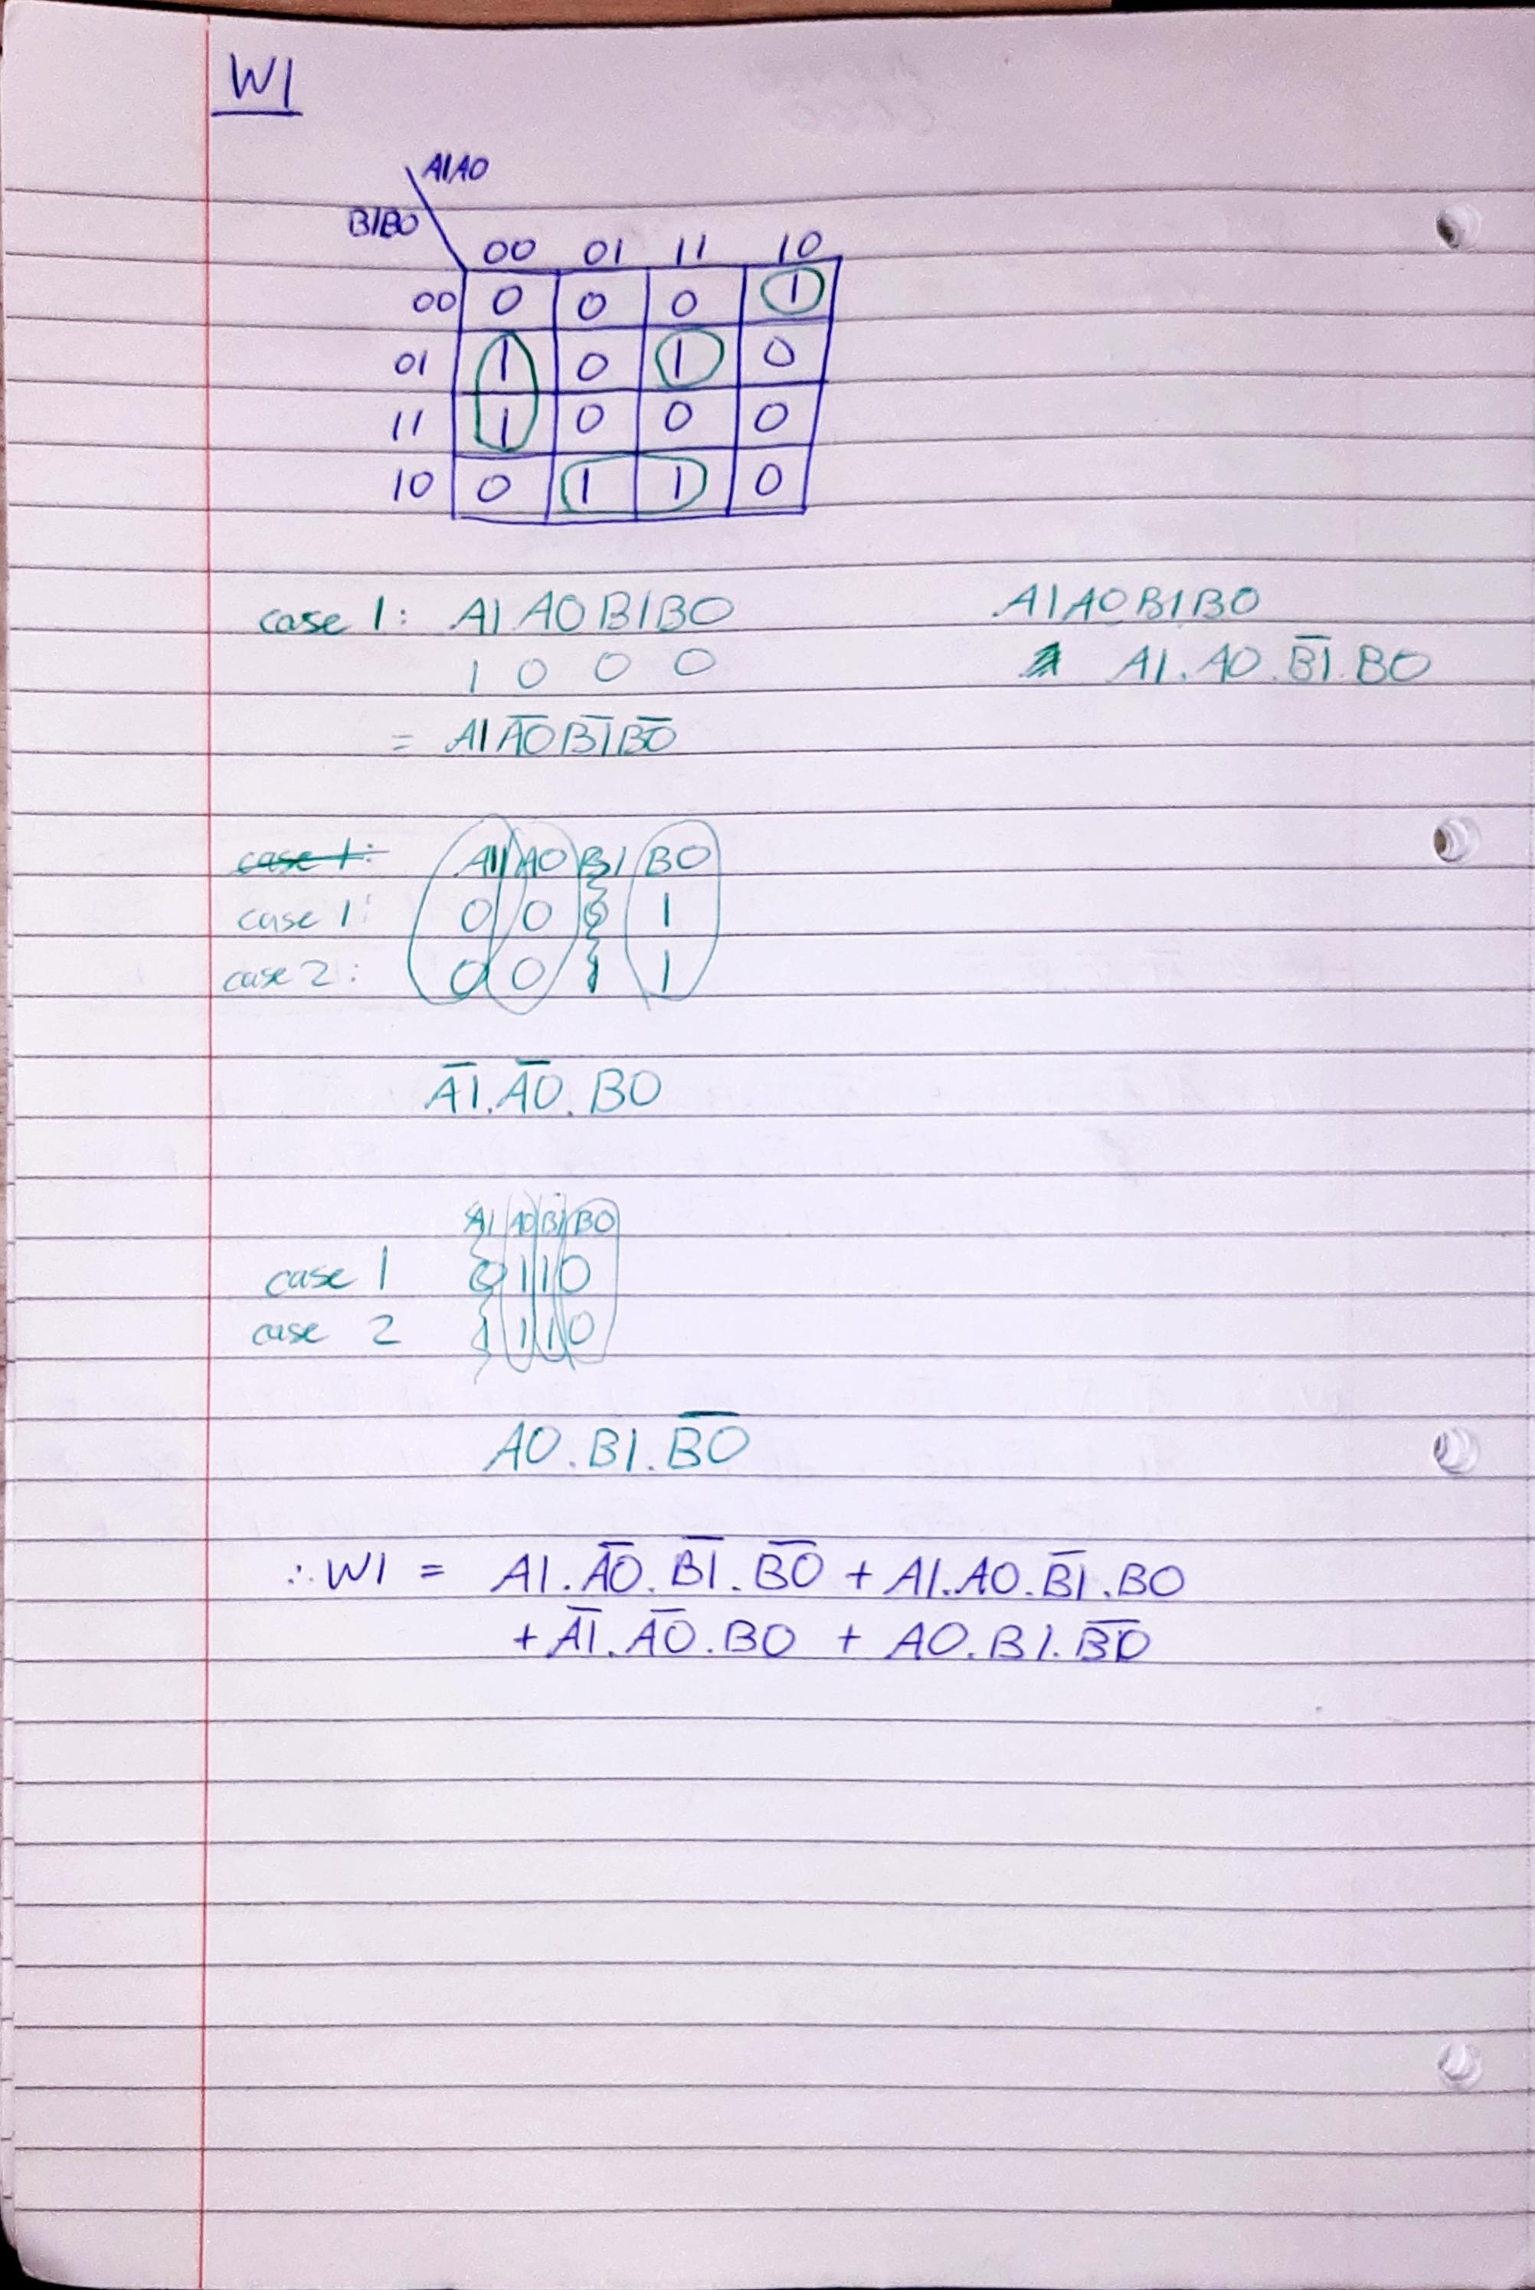and the sum of products for W1

Boolean function for W0

W0 = A1’.A0’.B1’.B0’ + A1’.A0’.B1’.B0 + A1’.A0’.B1.B0 + A1’.A0.B1’.B0 + A1’.A0.B1.B0’ + A1.A0’.B1’.B0’ + A1.A0’.B1.B0’ + A1.A0.B1’.B0 + A1.A0.B1.B0’ + A1.A0.B1.B0

Karnaugh map for W0  
and the sum of products for W0

LEDControl

Decide which player has won, if any. Only activate a player’s led if they won.

player A wins : 00

player B wins : 11

no one wins (draw) : 01

|  |  |  |  |  |
| --- | --- | --- | --- | --- |
| W1 | W0 |  | PlayerAWins | PlayerBWins |
| 0 | 0 |  | 1 | 0 |
| 0 | 1 |  | 0 | 0 |
| 1 | 1 |  | 0 | 1 |

PlayerAWins = W1’.W0’

PlayerBWins = W1.W0